**SVKM’s NMIMS**

**Mukesh Patel School of Technology Management & Engineering**

Program: B.Tech\MBA.Tech Computer Sem VI

**Course: Machine Learning**

Experiment No.07

PART A

**A.1 Aim: To implement feedforwad neural network**

Implementation of feedforward neural network:

**Task1:**

**Building a three-layer feed forward neural network from scratch by initializing random weights and biases.**

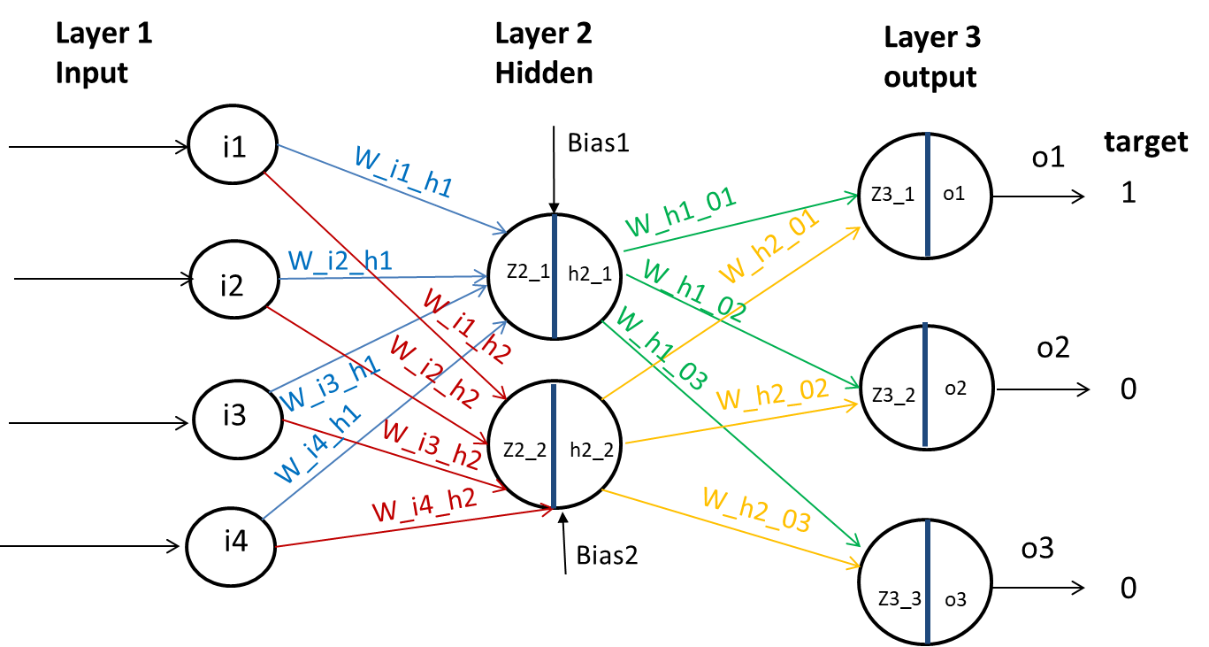

**Task2:**

**Compute the total squared error.**

**Task 3:**

**Change the initial weights and biases and compute the error again.**

**A.2 Prerequisite:**

Python Programming, Numpy

PART B

(PART B : TO BE COMPLETED BY STUDENTS)

***(Students must submit the soft copy as per following segments within two hours of the practical.)***

|  |  |
| --- | --- |
| Roll No. N052 | Name: Pratyush Kumar |
| Class : MBA Tech CE (div. D) | Batch : B2 |
| Date of Experiment: 02-02-2024 | Date of Submission: 03-03-2024 |
| Grade : |  |

**B.1 Tasks**

**Colab link:** https://colab.research.google.com/drive/1YUOplzNPvmPIaHW1x73AwXytFdg-YwFt?usp=sharing

* **Source Code**
* *"""  
   * This file contains code snippets to implement neural networks on iris dataset  
   * ML-E8  
   *  
   * Original file is located at: https://colab.research.google.com/drive/1YUOplzNPvmPIaHW1x73AwXytFdg-YwFt  
   * @author Pratyush Kumar (github.com/pratyushgta)  
  """*"""  
  ## EXPERIMENT 8 - Task 1  
    
  Building a three-layer feed forward neural network from scratch by initializing random weights and biases.  
  """  
    
  import pandas as pd  
  from sklearn.preprocessing import StandardScaler  
  import numpy as np  
    
  df= pd.read_csv("iris.csv")  
    
  df.head()  
    
  df.describe()  
    
  df.shape  
    
  df.dtypes  
    
  numeric_columns = df.select_dtypes(exclude=["object"]).columns  
  categorical_columns = df.select_dtypes(include=["object"]).columns  
    
  scaler = StandardScaler()  
    
  df[numeric_columns] = scaler.fit_transform(df[numeric_columns])  
    
  df = pd.get_dummies(df, columns=categorical_columns, dtype=int)  
    
  df.columns  
    
  df.head()  
    
  df.describe().round(2)  
    
  input = df.iloc[:, 0:4]  
    
  input.shape  
    
  input  
    
  np.random.seed(42)  
    
  w_i_h1 = np.random.rand(4,1)  
  w_i_h2 = np.random.rand(4,1)  
    
  w_h_o1 = np.random.rand(2,1)  
  w_h_o2 = np.random.rand(2,1)  
  w_h_o3 = np.random.rand(2,1)  
    
  bias1 = np.random.rand(1)  
  bias2 = np.random.rand(1)  
    
  print(w_i_h1, '\n')  
  print(w_i_h2, '\n')  
  print('\n')  
  print(w_h_o1, '\n')  
  print(w_h_o2, '\n')  
  print(w_h_o3, '\n')  
  print('\n')  
  print(bias1, '\n')  
  print(bias2, '\n')  
    
  h1_in = np.dot(input, w_i_h1) + bias1  
  h2_in = np.dot(input, w_i_h2) + bias2  
    
  print(h1_in.shape)  
  print(h2_in.shape)  
    
  def sigmoid(x):  
   return 1/(1 + np.exp(-x))  
    
  h1_out = sigmoid(h1_in)  
  h2_out = sigmoid(h2_in)  
    
  print(h1_out.shape)  
  print(h2_out.shape)  
    
  h_out = np.append(h1_out, h2_out, axis=1)  
  h_out.shape  
    
  o1_in = np.dot(h_out, w_h_o1)  
  o2_in = np.dot(h_out, w_h_o2)  
  o3_in = np.dot(h_out, w_h_o3)  
    
  o1 = sigmoid(o1_in)  
  o2 = sigmoid(o2_in)  
  o3 = sigmoid(o3_in)  
    
  print(o1.shape)  
  print(o2.shape)  
  print(o3.shape)
* **Input/ Output**

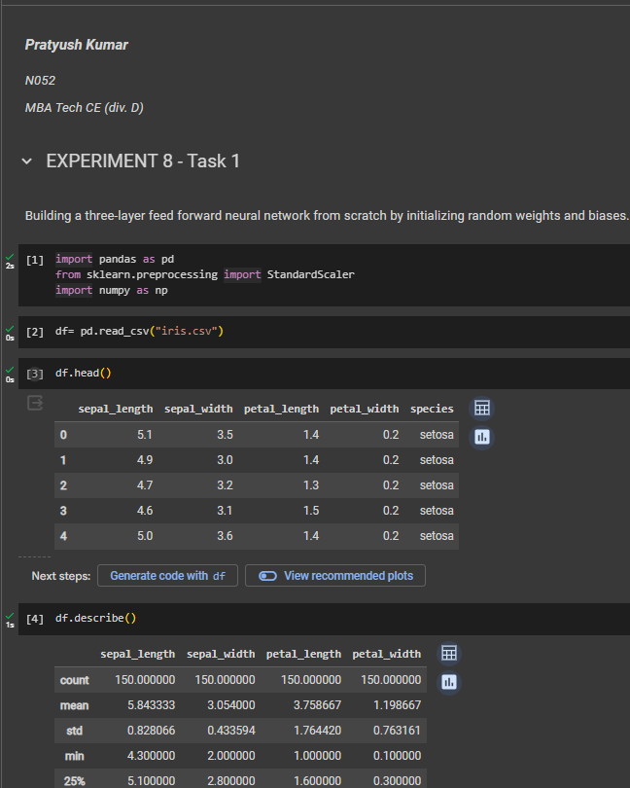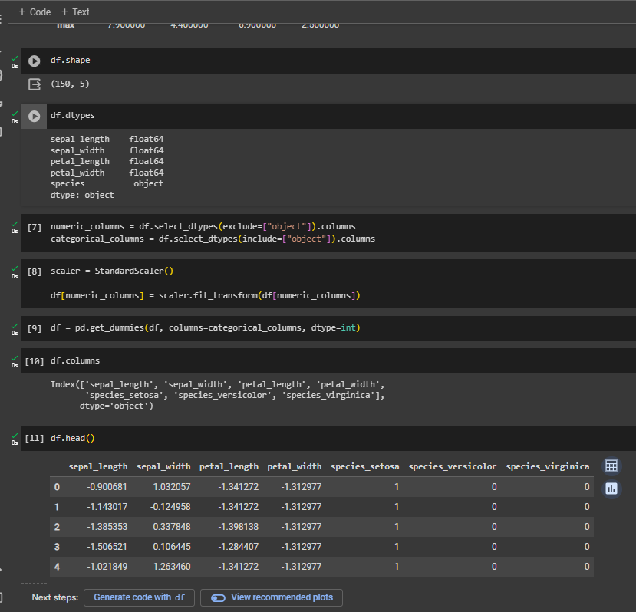

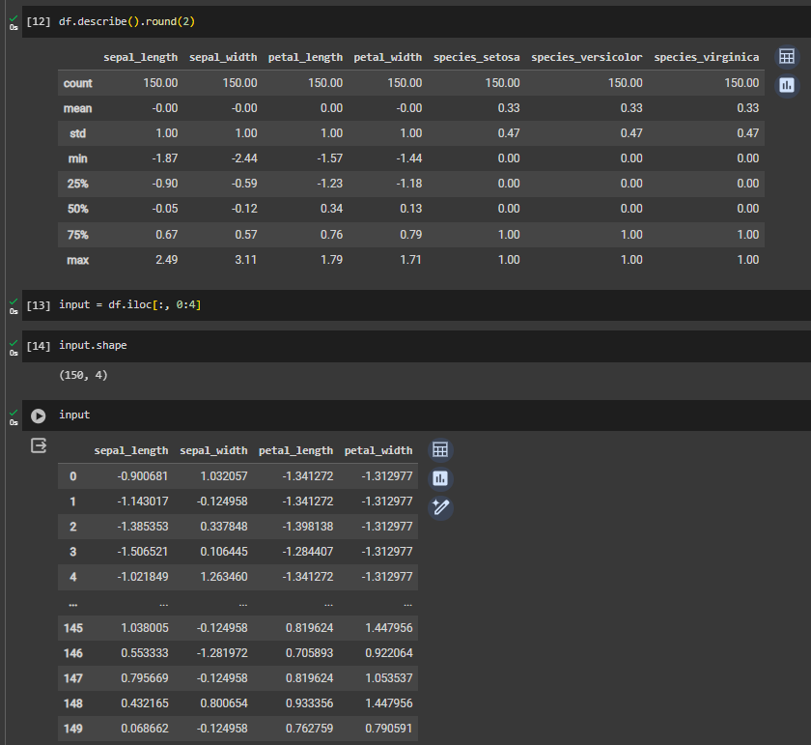

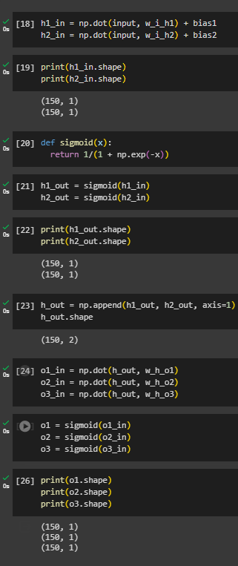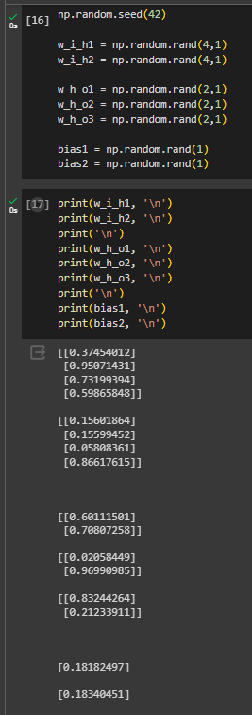

**B.2 Conclusion:**

*(Students must write the conclusion in their own words.)*

Implemented a three-layer feedforward architecture with randomly initialized weights and biases. Analyzed the processes of forward propagation, activation functions, and the role of parameters in determining network performance.